Mechatronics and Industrial Internet of Things

GPS -BASED VEHICLE TRACKING AND FLEET MANAGEMENT SYSTEM

PROJECT REPORT

BHAVESH PRAKASH G - 24MER005
VASANTHAN B – 24MER060
PRABHUKUMAR N – 24MER40
AJAY PRABHAV A – 24MER003
SANTHAKUMAR M – 24MEL065
DEEPAK C – 24MEL069
- Project Overview:
The IoT-Based GPS Vehicle Tracking and Fleet Management System is developed to provide real-time monitoring of vehicle location using a NEO-6M GPS module and an ESP8266 Wi-Fi microcontroller. The GPS module receives signals from GPS satellites and determines the geographical position of the vehicle, including location coordinates and other tracking information. The ESP8266 reads the GPS data and establishes an internet connection through a Wi-Fi network, enabling the information to be transmitted to a cloud platform for remote access and monitoring.
The collected GPS information is uploaded to Adafruit IO, where it can be viewed through a web-based dashboard from any location. The system provides important tracking parameters such as latitude, longitude, vehicle speed, number of GPS satellites, and vehicle location on a map. By combining GPS technology, IoT connectivity, Wi-Fi communication, cloud computing, and online monitoring, the project demonstrates an effective solution for vehicle tracking and fleet management applications.

- Project Statement:
Traditional vehicle monitoring methods may not provide convenient real-time information about the location and movement of vehicles. Monitoring vehicles manually can be difficult, especially when they operate over large geographical areas or when multiple vehicles need to be tracked simultaneously. The absence of continuous location monitoring can make it challenging to access accurate vehicle information remotely and maintain effective fleet management.
Therefore, there is a need for an IoT-based vehicle tracking system that can:
- Monitor vehicle location in real time.
- Obtain GPS coordinates continuously.
- Measure vehicle speed.
- Display vehicle location on an online map.
- Allow remote monitoring through the Internet.
- Store GPS information in the cloud.
- Provide continuous tracking for fleet management applications.
The proposed system addresses these requirements using an ESP8266 Wi-Fi microcontroller, NEO-6M GPS module, Wi-Fi communication, and Adafruit IO cloud platform. The system continuously collects GPS information and uploads it to the cloud, enabling users to monitor vehicle location and movement remotely through a web-based dashboard.

- Proposed Solution:
The proposed solution combines GPS and IoT technologies to provide real-time vehicle tracking and fleet monitoring. The system consists of an ESP8266 Wi-Fi microcontroller, a NEO-6M GPS module, a Wi-Fi network, and a suitable power supply. The NEO-6M GPS module receives signals from GPS satellites and determines the geographical position of the vehicle. The ESP8266 reads the GPS information through serial communication and processes the received data.
The ESP8266 then connects to a Wi-Fi network and uploads the GPS information to Adafruit IO through the internet. The cloud platform receives and stores parameters such as latitude, longitude, vehicle speed, and satellite count. These values can be viewed remotely through the Adafruit IO dashboard, where the vehicle location can also be displayed on a map. This enables continuous monitoring of vehicle movement and provides a simple cloud-based solution for vehicle tracking and fleet management applications.
Hardware:
- ESP8266
- NEO-6M GPS Module
- Wi-Fi Network
- Power Supply
Software:
- Arduino IDE
- Tiny GPS Plus Library
- Software Serial Library
- Adafruit IO Arduino Library
- Adafruit IO Dashboard

- System Architecture:

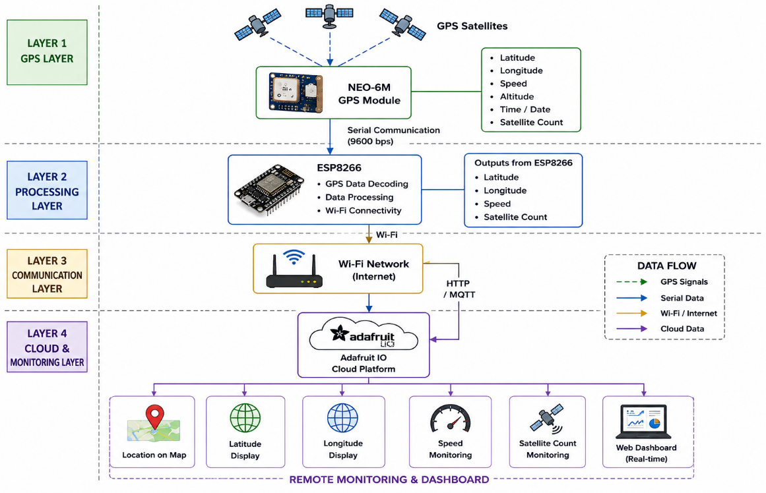

- Circuit Table:

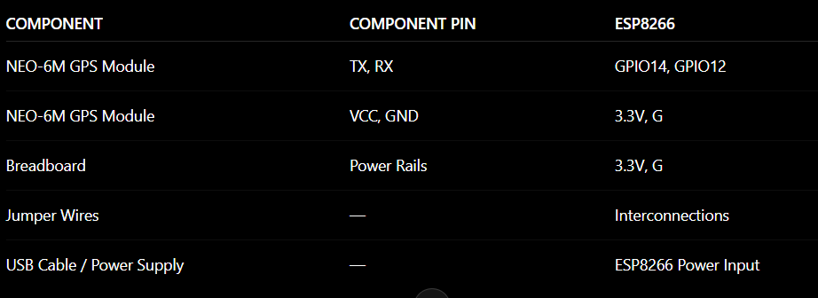

- Circuit Design:

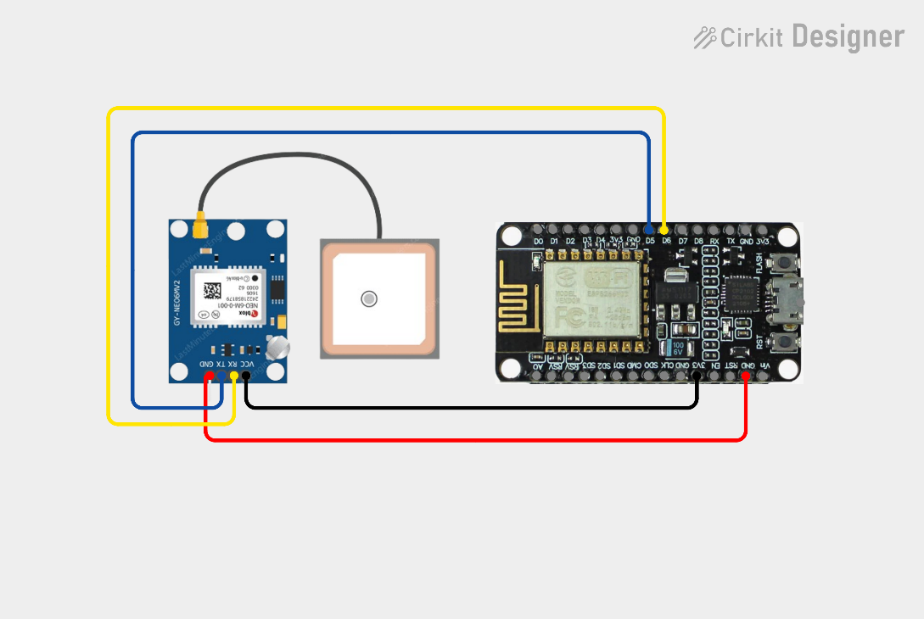

- Algorithm:
Step 1: Start the system.
Step 2: Initialize the ESP8266 Wi-Fi microcontroller.
Step 3: Initialize serial communication with the NEO-6M GPS module.
Step 4: Connect the ESP8266 to the configured Wi-Fi network.
Step 5: Establish communication with the Adafruit IO cloud platform.
Step 6: Receive GPS data from the NEO-6M GPS module.
Step 7: Extract latitude, longitude, speed, and satellite count from the GPS data.
Step 8: Process and validate the received GPS information.
Step 9: Upload the GPS parameters to Adafruit IO.
Step 10: Display the vehicle location and tracking information on the cloud dashboard.
Step 11: Wait for the predefined update interval.
Step 12: Repeat the process continuously for real-time vehicle tracking.

- Coding:
#include <ESP8266WiFi.h>
#include "AdafruitIO_WiFi.h"
#include <TinyGPSPlus.h>
#include <SoftwareSerial.h>
#define WIFI_SSID "Harrish"
#define WIFI_PASS "Password"
#define IO_USERNAME "saravanakarthiksr"
#define IO_KEY "aio_idPg82y91fmNVXL0iJA71zKwH97q"
AdafruitIO_WiFi io(
IO_USERNAME,
IO_KEY,
WIFI_SSID,
WIFI_PASS
);
AdafruitIO_Feed *latitudeFeed = io.feed("latitude");
AdafruitIO_Feed *longitudeFeed = io.feed("longitude");
AdafruitIO_Feed *speedFeed = io.feed("speed");
AdafruitIO_Feed *satelliteFeed = io.feed("satellites");
AdafruitIO_Feed *locationFeed = io.feed("gps-location");
#define GPS_RX_PIN 14
#define GPS_TX_PIN 12
Software Serial gps Serial(GPS_RX_PIN, GPS_TX_PIN);
Tiny GPSPlus gps;
unsigned long lastUpload = 0;
const unsigned long uploadInterval = 10000; // 10 seconds
void setup()
{
Serial.begin(115200);
delay(1000);
Serial.println();
Serial.println();
Serial.println("GPS VEHICLE TRACKING SYSTEM");
Serial.println();
Serial.println("ESP8266 + NEO-6M + Adafruit IO");
Serial.println();
gpsSerial.begin(9600);
Serial.println("GPS started.");
Serial.println("GPS Baud Rate: 9600");
Serial.println();
Serial.println("Connecting to Adafruit IO...");
io.connect();
while (io.status() < AIO_CONNECTED)
{
Serial.print(".");
delay(500);
}
Serial.println();
Serial.println("Adafruit IO connected!");
Serial.println();
}
void loop()
{
io.run();
while (gpsSerial.available() > 0)
{
char c = gpsSerial.read();
gps.encode(c);
}
if (gps.location.isUpdated())
{
double latitude = gps.location.lat();
double longitude = gps.location.lng();
double speed = gps.speed.kmph();
int satellites = gps.satellites.value();
Serial.println("");
Serial.print("Latitude : ");
Serial.println(latitude, 6);
Serial.print("Longitude : ");
Serial.println(longitude, 6);
Serial.print("Speed : ");
Serial.print(speed, 2);
Serial.println(" km/h");
Serial.print("Satellites: ");
Serial.println(satellites);
if (millis() - lastUpload >= uploadInterval)
{
lastUpload = millis();
Serial.println();
Serial.println("Uploading GPS data to Adafruit IO...");
latitudeFeed->save(latitude);
Serial.print("Latitude uploaded: ");
Serial.println(latitude, 6);
longitudeFeed->save(longitude);
Serial.print("Longitude uploaded: ");
Serial.println(longitude, 6);
speedFeed->save(speed);
Serial.print("Speed uploaded: ");
Serial.print(speed, 2);
Serial.println(" km/h");
satelliteFeed->save(satellites);
Serial.print("Satellites uploaded: ");
Serial.println(satellites);
double altitude = 0;
if (gps.altitude.isValid())
{
altitude = gps.altitude.meters();
}
locationFeed->save(
speed,
latitude,
longitude,
altitude
);
Serial.println("Map location uploaded.");
Serial.println("");
Serial.println("UPLOAD COMPLETE");
Serial.println("");
Serial.println();
}
}
delay(10);
}

- System Working:

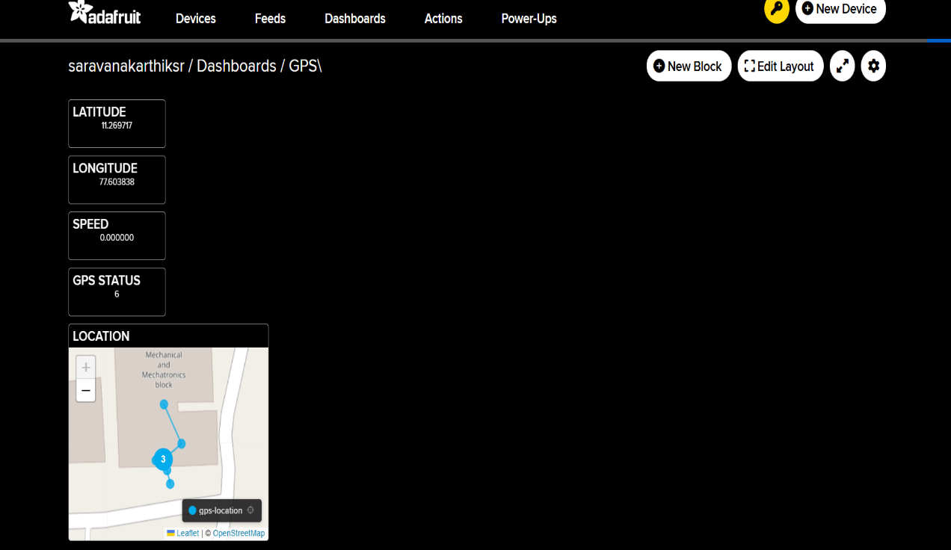

- Working sequence:
GPS Satellites → NEO-6M GPS Module → ESP8266 Data Processing → Wi-Fi Network → Adafruit IO Cloud → Dashboard Monitoring → Vehicle Location Tracking

- Bill of Materials:
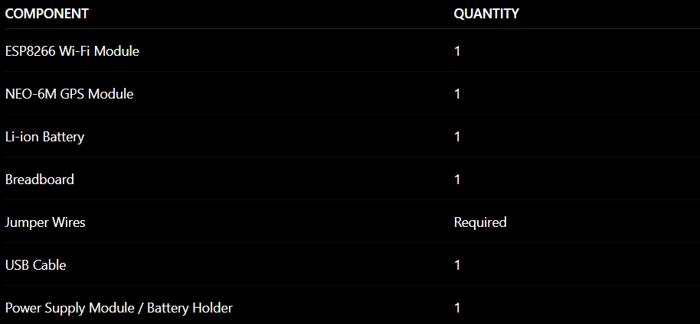

- Prototype Implementation:

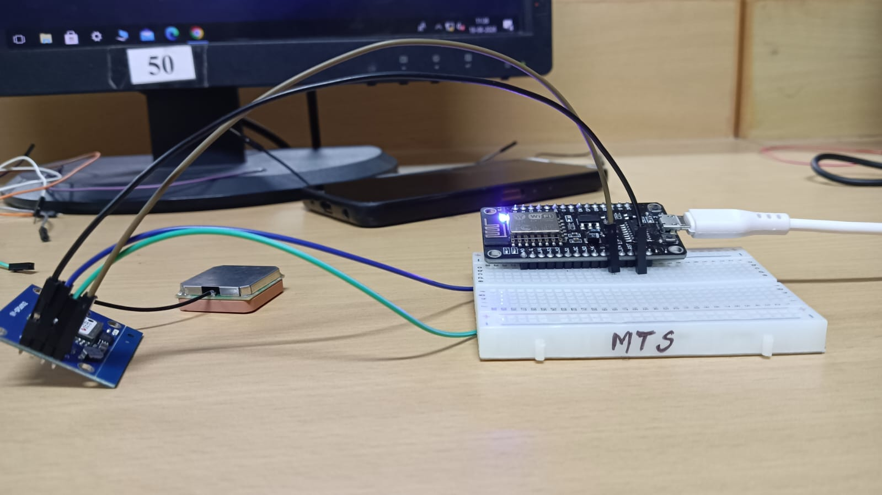
- Results and Performance Analysis:
Performance:
The system provides:
- Real-time vehicle location tracking.
- Continuous monitoring of latitude and longitude.
- Vehicle speed measurement.
- GPS satellite count monitoring.
- Wireless data transmission through Wi-Fi.
- Cloud-based data storage using Adafruit IO.
- Map-based vehicle location visualization.
- Remote monitoring through a web dashboard.
Advantages:
- Low-cost IoT-based vehicle tracking solution.
- Provides real-time vehicle location information.
- Supports remote monitoring through the Internet.
- Cloud-based storage of GPS data.
- Displays vehicle position on an online map.
- Easy to implement using ESP8266 and NEO-6M.
- Suitable for vehicle tracking and fleet management applications.
Limitations:
- GPS performance depends on satellite signal availability.
- Indoor environments may reduce GPS reception and delay obtaining a valid GPS fix.
- The system requires Wi-Fi and Internet connectivity for cloud updates.
- GPS accuracy can vary depending on environmental conditions.
- The first GPS fix may take some time after power-up.
- Cloud monitoring is not available when Internet connectivity is lost.

